SQL Server Integration Services

# Module 05: Deployment

1. Open the Project Mod5SupportLab.
2. Review and update the connection string to match your server.
3. Test the package in Visual Studio before deployment.
4. Right-click on Project Name under Solution Explorer and click Deploy.
5. Click next until you get to Deployment Target, make sure to select SSIS in SQL Server.
6. Next Screen Enter in Server Name and click Connect.
7. Under Path click on Browse, select SSISDB and click New Folder.
8. Name your project “Mod5Lab1” and click OK.
9. Select folder and click OK. Click Next and Deploy.
10. In SQL Server Management studio go to Integration Services Catalog and refresh to see the new project and package deployed.

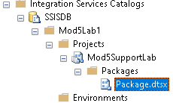

1. Test the package by right clicking on it and selecting Execute. When we go to Execute Dialog box, we get lots of warnings for missing values. Because each value is required. Click on the three dots beside it to select the design value and click OK to execute. After execution review the dashboard and report by right clicking on SSISDB and going to Reports > Standard Reports > Dashboard.
2. The package should execute successfully. Next let’s configure Environment variables to allow us to run the package against different parameters.
3. Create two new environments under the project.

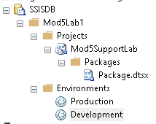

1. Right click on each environment and go to properties. In the dialog box, go to Variables. Define a new variable FilePath, type String, value set (C:\Temp\ for Production) and (C:\Temp2\ for Development).

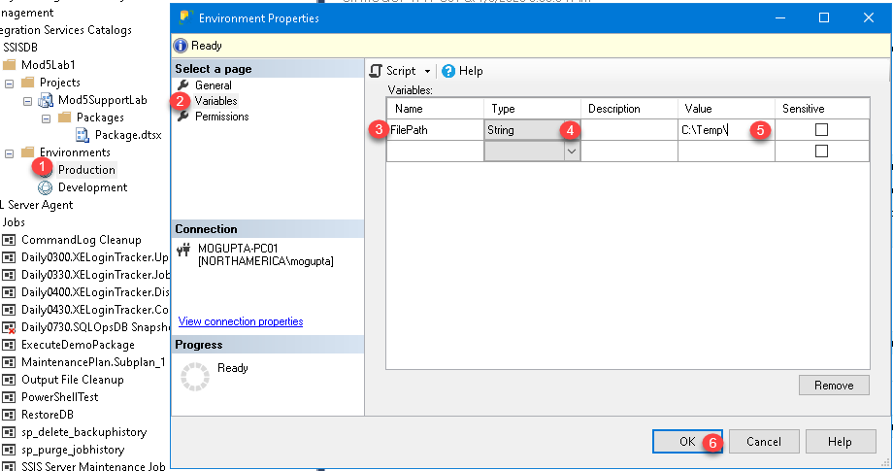

1. Next, register the environment to the Project. Right click on Project Name and go to configure. In the dialog box, go to References. Click on Add. Add both Production and Development environment.

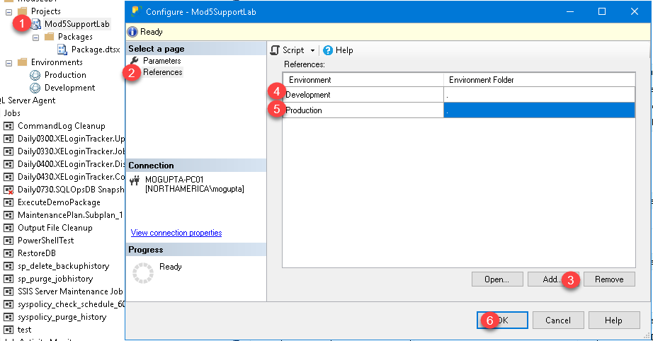

1. Apply the Variable for FilePath to the parameter ExportPath. Click on references, click on the “…”, select use environment variable, select FilePath.

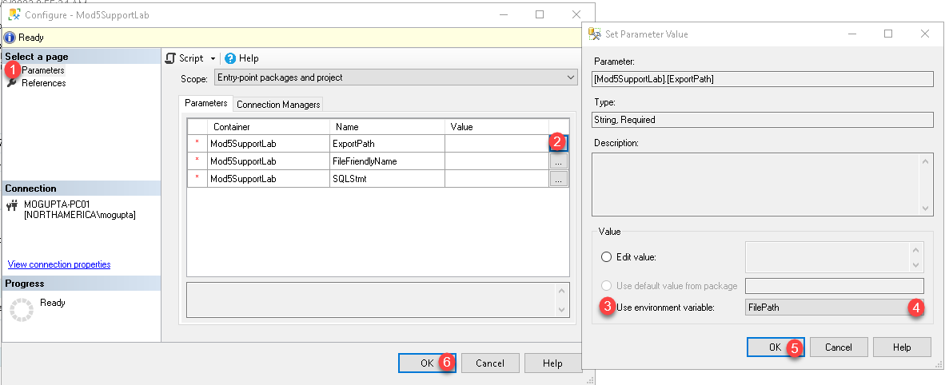

1. Now let’s schedule a job for it, make sure your SQL Server Agent is running. Right click on Jobs and select a new job.

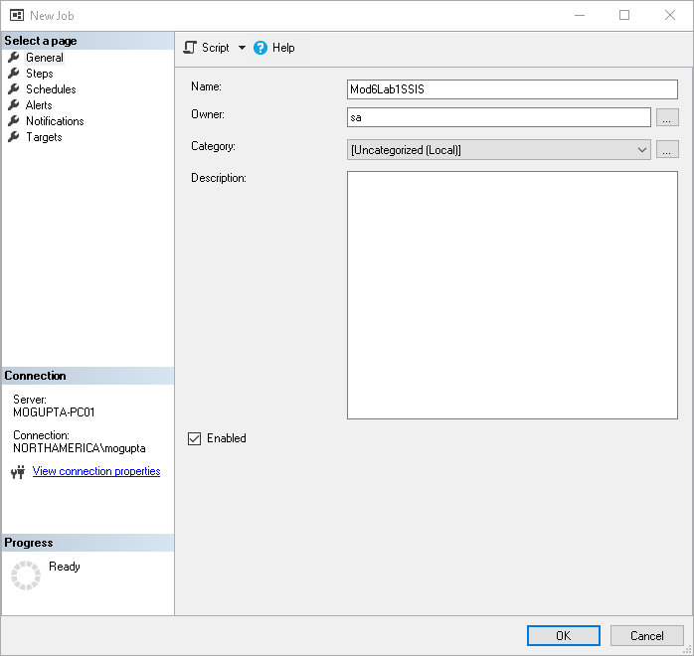

1. Under the steps click new. In the new step set the name, type, run as account (Agent), Server, and select the package.

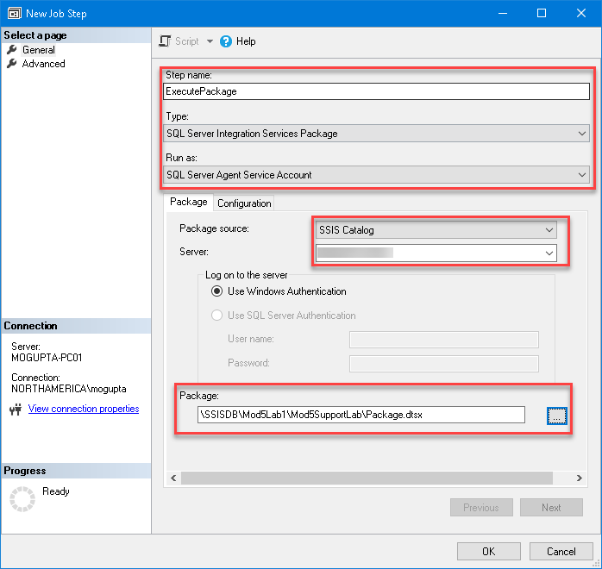

1. Click on Configuration and select environment to run for.

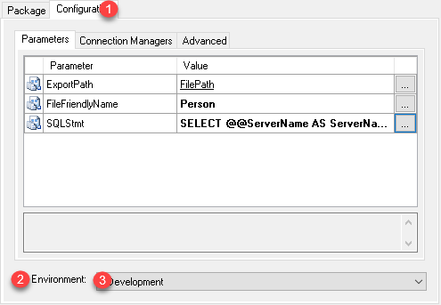

1. Try running the job manually, by right clicking on the job and select Start at step.
2. Create a new job pointing to Production environment – note the variable names must be same in both environments.